Project Summary

Batch details | DSE Oct 20 Online Batch
Team members | Mr. Gaurav Shirbhate  Mr. Niraj Kumar  Ms. Priyanka Gummuluri  Mr. Patlolla Vinay Kumar Reddy  Mr. Rajat Kukkar
Domain of Project | Telecommunication
Proposed project title | Telco Customer Churn Prediction
Group Number | 4
Team Leader | Mr. Rajat Kukkar
Mentor Name | Mr. Sravan Malla

Project Details

OVERVIEW:
In order to tackle customer churn problem we must recognize the churners before they churn, so developing a model which predicts the future churners seems to be vital. The purpose of this model is to develop and design an effective and efficient model for customer churn prediction in telecommunication industry.

Business problem statement (GOALS):
- Business Problem Understanding:
In the competitive Telecom industry, public policies and standardization of mobile communication allow customers to easily switch over from one carrier to another resulting in a strained fluidic market. Churn prediction, or the task of identifying customers who are likely to discontinue use of a service, is an important and lucrative concern of the Telecom industry.

- Business Objective:

To Predict Customer Churn Model based on various Variables like Customer Profile, Customer Account Information & Services that he has signed up for etc.

Data Description:
The data set includes information about:
- Customers who left within the last month – the column is called Churn
- Services that each customer has signed up for – phone, multiple lines, internet, online security, online backup, device protection, tech support, and streaming TV and movies
- Customer account information – how long they’ve been a customer, contract, payment method, paperless bill.

Data Size:
- Number of Columns: 21
- Number of Rows: 7043
- Total Number of Records: 7043
Data Dictionary:
- Customer ID: It is the unique ID of each customer.
- Gender: Whether the customer is a male or a female.
- Senior citizen: Whether the customer is a senior citizen or not (1, 0)
- Partner: Whether the customer has a partner or not (Yes, No)
- Tenure: Number of months the customer has stayed with the company.
- Dependents: Whether the customer has dependents or not (Yes, No)
- Phone Service: Whether the customer has a phone service or not (Yes, No)
- Multiple Lines: Whether the customer has multiple lines or not (Yes, No, no phone service)
- Internet Service: Customer’s Internet Service Provider (DSL , Fiber optic, No)
- Online Security: Whether the customer has online security or not (Yes, No, no internet service)
- Online Backup: Whether the customer has online backup or not (Yes, No, no internet service)
- Device Protection: Whether the customer has device protection or not (Yes, No, No internet service)
- Tech Support: Whether the customer has tech support or not (Yes, No, No internet service)
- Streaming TV: Whether the customer has streaming TV or not (Yes, No, No internet service)
- Streaming Movies: Whether the customer has streaming movies or not (Yes, No, No internet service)
- Contract: The contract term of the customer (Month-to-month, One year, Two year)
- Paperless Billing: Whether the customer has paperless billing or not (Yes, No)
- Payment Method: The customer’s payment method (Electronic check, Mailed check, Bank transfer (automatic), Credit card (automatic))
- Monthly Charges: The amount charged to the customer monthly
- Total Charges: The total amount charged to the customer
- Churn: Whether the customer churned or not (Yes or No).

- Approach:

- DATA ANALYSIS, CLEANING/ PREPROCESSING: The pre-processing of the dataset before performing ML functions involves the following:
  - Descriptive Analysis: Descriptive statistics are used to describe the basic features of the data in a study. They provide simple summaries about the sample and the measures. Together with simple graphics analysis, they form the basis of virtually every quantitative analysis of data. Measures of variability help communicate the spread of distribution by describing the shape and spread of the data set.
  - Inferential Analysis: Validating the inferences which are found with the help of descriptive analysis (Graphs) with the help of respective statistical tests if needed.
  - Treating Outliers: Checking and analyzing for presence of Outliers in the numerical columns and treating those outliers using the IQR method or any relevant method.
  - Treating Missing Values: Null values in the variables must be treated with suitable methods.
  - Encoding Categorical Variables: Since, machine learning models are based on Mathematical equations and we can intuitively understand that it would cause some problem if we can either keep the Categorical data by encoding the categorical variable or we can drop by checking whether we need the variable for further modelling process because we would only want numbers in the equations.
  - Dropping Unnecessary Columns: We are removing the columns which do not contribute to the model building or the columns which are of less, or of no importance

- Exploratory Data Analysis:
Exploratory Data Analysis or (EDA) is understanding the data sets by summarizing their main characteristics often plotting them visually. This step is very important especially when we arrive at modeling the data in order to apply Machine learning. Plotting in EDA consists of Bar plot, Box plot, Scatter plot and many more using Univariate, Bivariate and Multivariate Analysis.

Data Preparation:
  - Scaling: It helps to normalize the data within a particular range and as well as in speeding up the calculations in an algorithm.
  - Train and Test Split of the Data: The data is split into train and test in required ratio.

- Model Building:
We will try to fit/train and test with below ML models and compare the performances.

- Logistic Regression
- Navis Bayes
- Random Forest
- Decision Tree
- KNN Classifier

- Model Evaluation:
Model Evaluation: Below metrics are used to evaluate the multi classification models performance.
- Accuracy
- Precision
- Recall
- F1-score
- Confusion Matrix
- RoC/AuC Score

- Model Deployment:
In this step, we will save the best model(pickle) and come up with a method or function which takes text review as input and product category as output. We can try to productionize the deployment using flask.

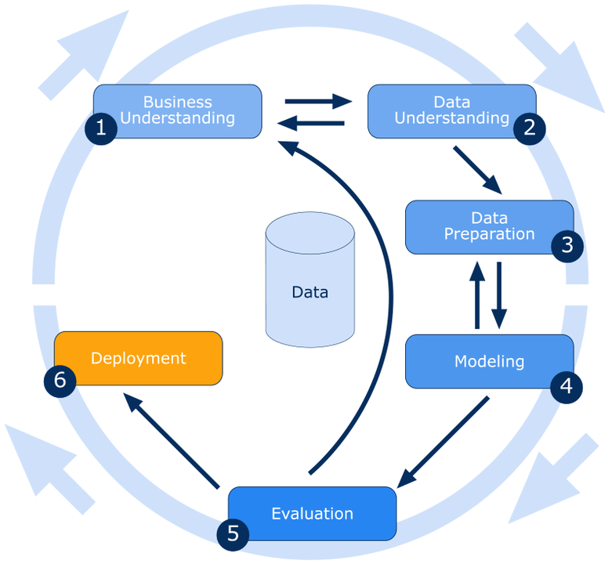

- Conclusions:
We will create a precise model which predicts the churn status of customers from the given data set.

REFERENCES:
- https://www.kaggle.com/blastchar/telco-customer-churn
- https://www.diva-portal.org/smash/get/diva2:1020047/FULLTEXT01.pdf
- https://paginas.fe.up.pt/~ec/files_0405/slides/02%20CRISP.pdf
- https://en.wikipedia.org/wiki/Cross-industry_standard_process_for_data_mining

***********************************************************

